**Tutorial: Create a multi-container app with Docker Compose**

**Applies to:** yesVisual Studio noVisual Studio for Mac noVisual Studio Code

In this tutorial, you'll learn how to manage more than one container and communicate between them when using Container Tools in Visual Studio. Managing multiple containers requires *container orchestration* and requires an orchestrator such as Docker Compose or Service Fabric. Here, we'll use Docker Compose. Docker Compose is great for local debugging and testing in the course of the development cycle.

The completed sample that you'll create in this tutorial may be found on GitHub at <https://github.com/MicrosoftDocs/vs-tutorial-samples> in the folder *docker/ComposeSample*.

**Prerequisites**

* [Docker Desktop](https://hub.docker.com/editions/community/docker-ce-desktop-windows)
* [Visual Studio 2022](https://visualstudio.microsoft.com/downloads/) with the **Web Development**, **Azure Tools** workload, and/or **.NET cross-platform development** workload installed. This includes .NET Core 3.1 and .NET 6 development tools.

**Use docker-compose command**

Other than launch the docker compose through Visual Studio frontend mode you can also launch Windows Power Shell to run docker-compost from the background and manage it

* To start composed containers at the background: **docker-compose up -d**

* To stop and remove composed containers: **docker-compose down**

**Create a Web Application project**

In Visual Studio, create an **ASP.NET Core Web App** project, named WebFrontEnd, to create a web application with Razor pages.

**Note**

In Visual Studio 2022 17.2 and later, you can use Azure Functions for this project instead.

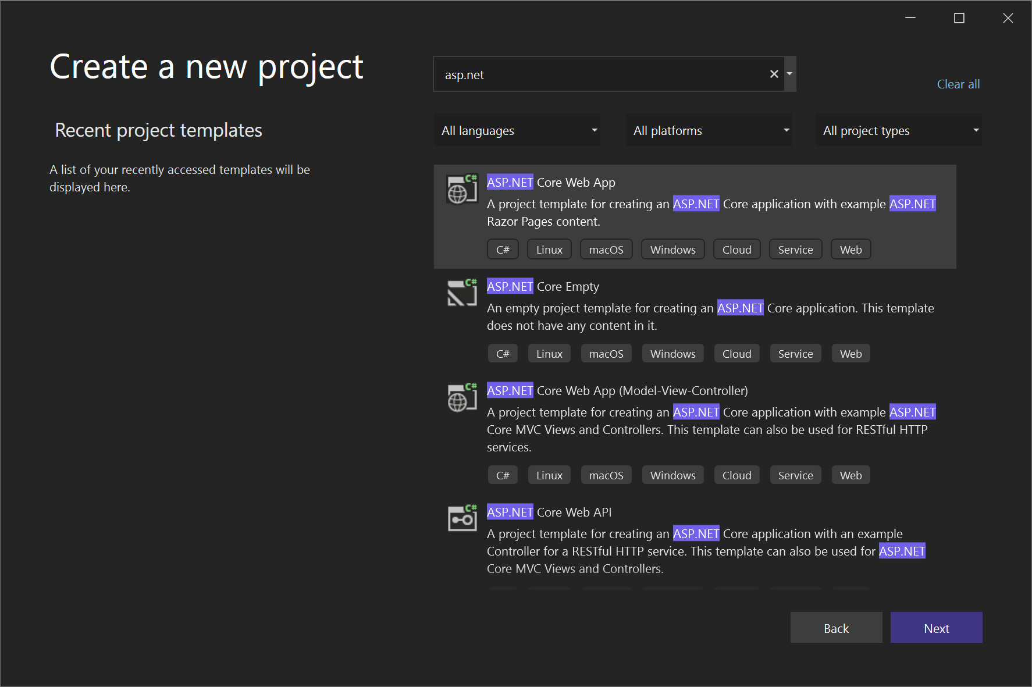

Do not select **Enable Docker Support**. You'll add Docker support later.

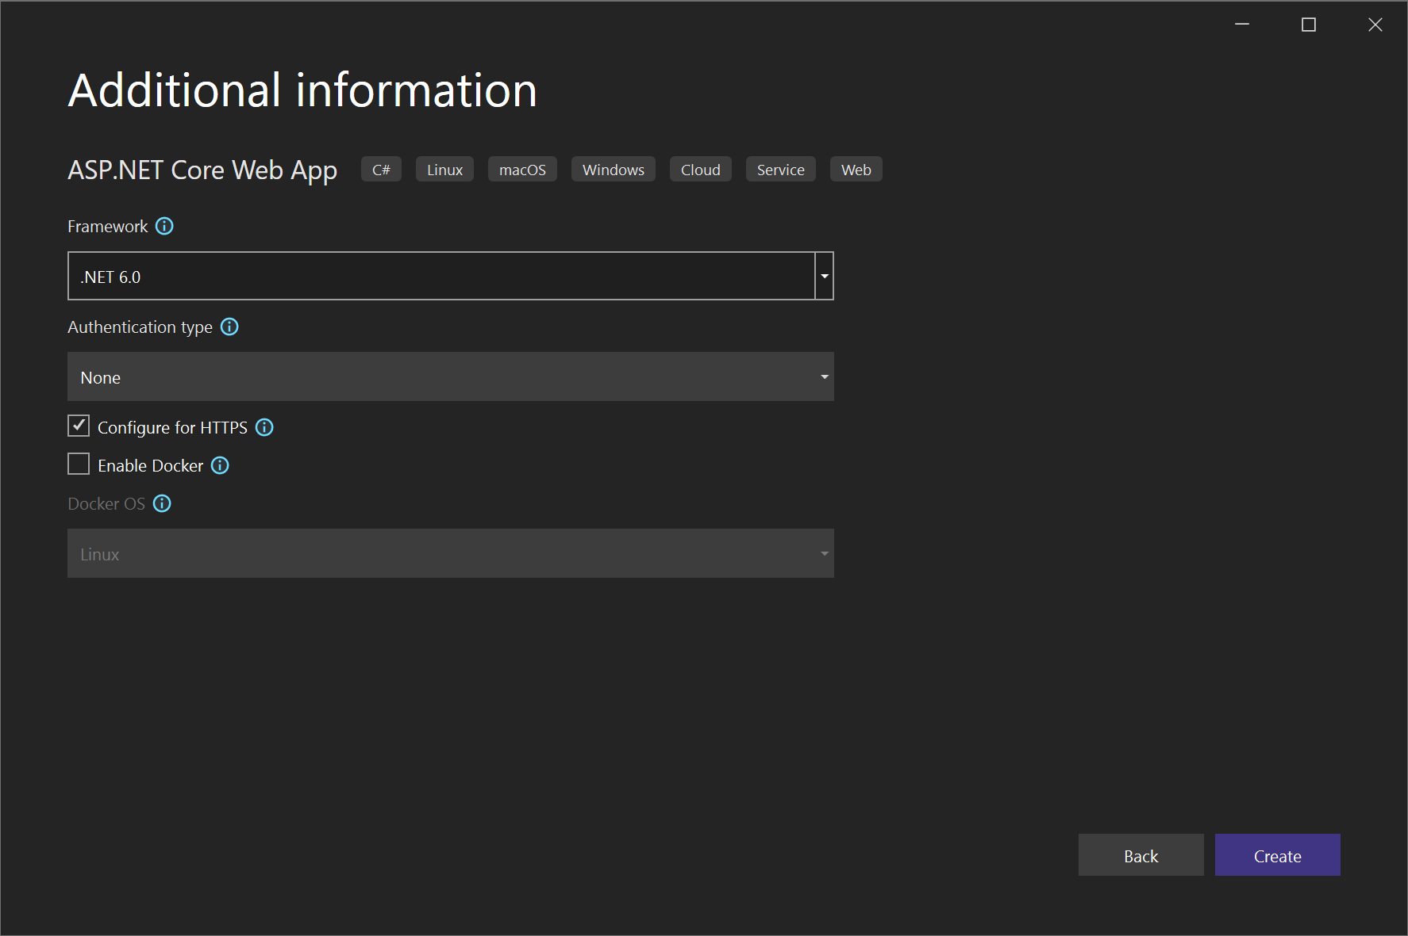

**Create a Web API project**

1. Add a project to the same solution and call it *WebAPI*. Select **API** as the project type, and clear the checkbox for **Configure for HTTPS**. In this design, we're only using SSL for communication with the client, not for communication from between containers in the same web application. Only WebFrontEnd needs HTTPS and the code in the examples assumes that you have cleared that checkbox. In general, the .NET developer certificates used by Visual Studio are only supported for external-to-container requests, not for container-to-container requests.

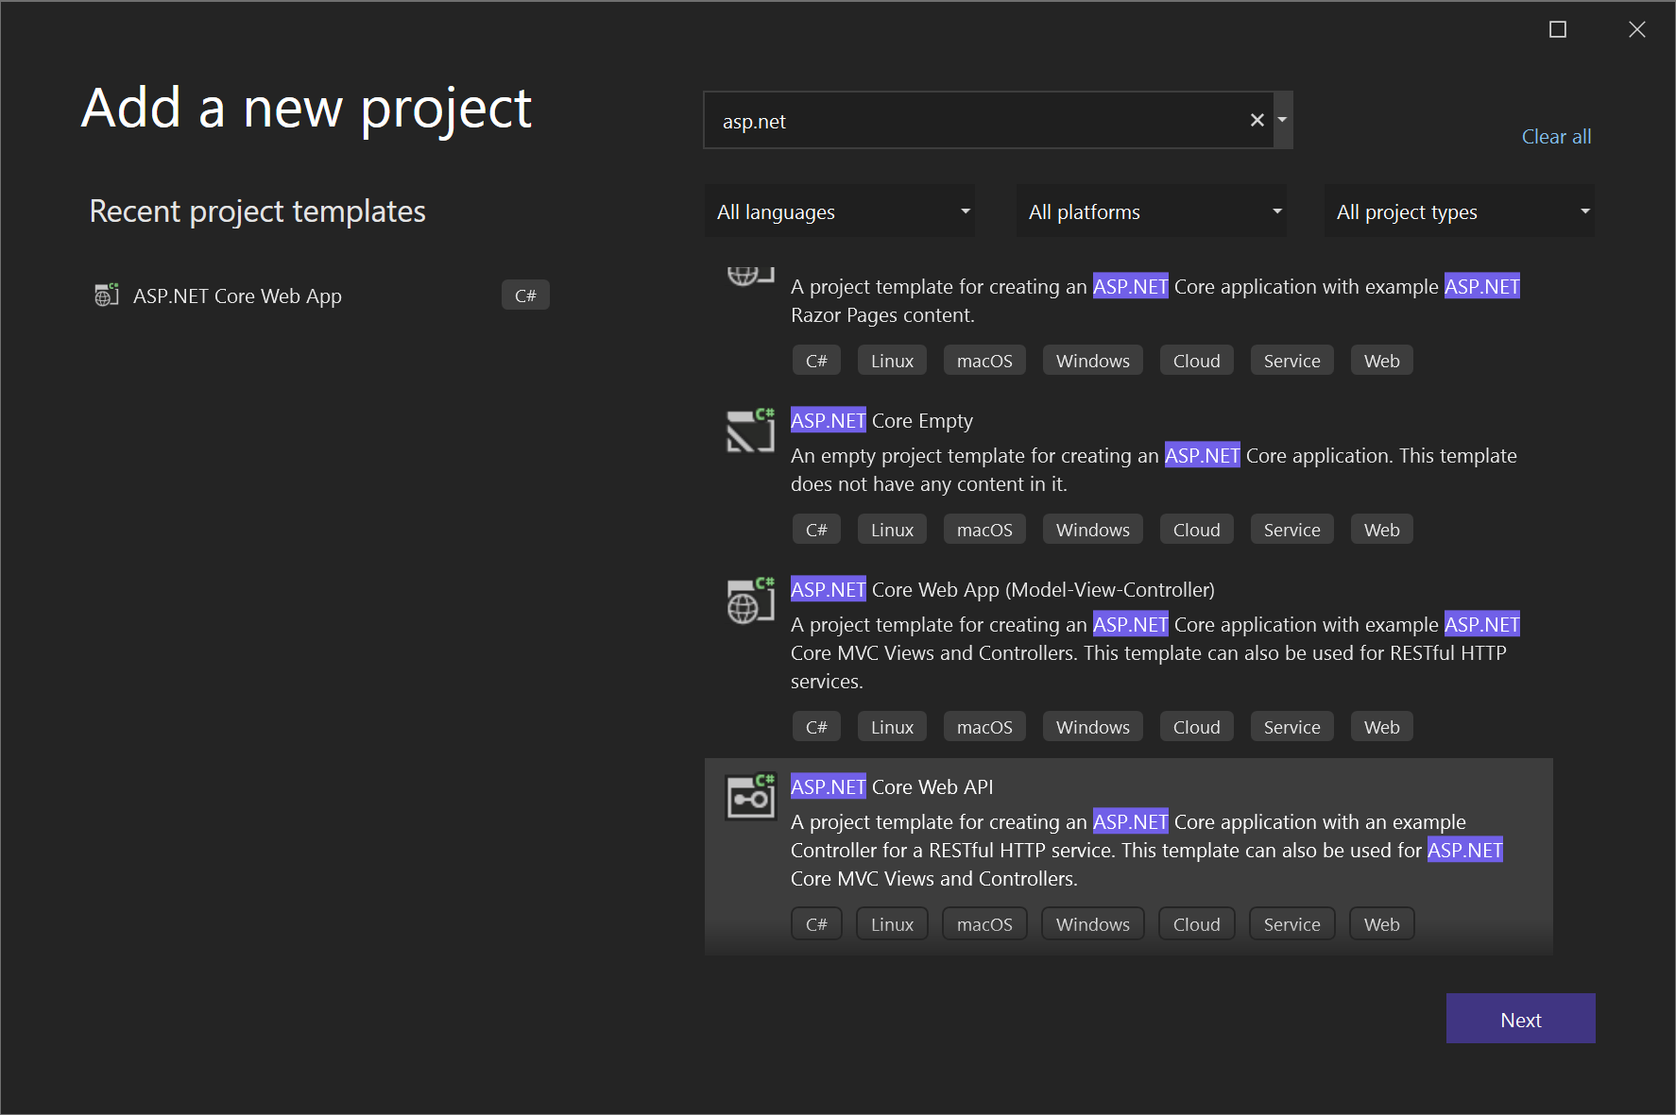

1. Add support for Redis Cache. Add the NuGet package Microsoft.Extensions.Caching.StackExchangeRedis (not StackExchange.Redis). In *Program.cs*, add the following lines, just before var app = builder.Build():

C#Copy

builder.Services.AddStackExchangeRedisCache(options =>

{

options.Configuration = "redis:6379"; // redis is the container name of the redis service. 6379 is the default port

options.InstanceName = "SampleInstance";

});

1. Add using directives in *Program.cs* for Microsoft.Extensions.Caching.Distributed and Microsoft.Extensions.Caching.StackExchangeRedis.

C#Copy

using Microsoft.Extensions.Caching.Distributed;

using Microsoft.Extensions.Caching.StackExchangeRedis;

1. In the Web API project, delete the existing *WeatherForecast.cs* and *Controllers/WeatherForecastController.cs*, and add a file under Controllers, *CounterController.cs*, with the following contents:

C#Copy

using Microsoft.AspNetCore.Mvc;

using Microsoft.Extensions.Caching.Distributed;

using StackExchange.Redis;

namespace WebApi.Controllers

{

[ApiController]

[Route("[controller]")]

public class CounterController : ControllerBase

{

private readonly ILogger<CounterController> _logger;

private readonly IDistributedCache _cache;

public CounterController(ILogger<CounterController> logger, IDistributedCache cache)

{

_logger = logger;

_cache = cache;

}

[HttpGet(Name = "GetCounter")]

public string Get()

{

string key = "Counter";

string? result = null;

try

{

var counterStr = _cache.GetString(key);

if (int.TryParse(counterStr, out int counter))

{

counter++;

}

else

{

counter = 0;

}

result = counter.ToString();

_cache.SetString(key, result);

}

catch(RedisConnectionException)

{

result = $"Redis cache is not found.";

}

return result;

}

}

}

The service increments a counter every time the page is accessed and stores the counter in the Redis cache.

**Add code to call the Web API**

1. In the WebFrontEnd project, open the *Index.cshtml.cs* file, and replace the OnGet method with the following code.

C#Copy

public async Task OnGet()

{

using (var client = new System.Net.Http.HttpClient())

{

// Call *mywebapi*, and display its response in the page

var request = new System.Net.Http.HttpRequestMessage();

// webapi is the container name

request.RequestUri = new Uri("http://webapi/Counter");

var response = await client.SendAsync(request);

string counter = await response.Content.ReadAsStringAsync();

ViewData["Message"] = $"Counter value from cache :{counter}";

}

}

**Note**

In real-world code, you shouldn't dispose HttpClient after every request. For best practices, see [**Use HttpClientFactory to implement resilient HTTP requests**](https://docs.microsoft.com/en-us/dotnet/architecture/microservices/implement-resilient-applications/use-httpclientfactory-to-implement-resilient-http-requests).

1. In the *Index.cshtml* file, add a line to display ViewData["Message"] so that the file looks like the following code:

CSHTMLCopy

@page

@model IndexModel

@{

ViewData["Title"] = "Home page";

}

<div class="text-center">

<h1 class="display-4">Welcome</h1>

<p>Learn about <a href="/aspnet/core">building Web apps with ASP.NET Core</a>.</p>

<p>@ViewData["Message"]</p>

</div>

This code will display the value of the counter returned from the Web API project.

**Add Docker Compose support**

1. In the WebFrontEnd project, choose **Add > Container Orchestrator Support**. The **Docker Support Options** dialog appears.
2. Choose **Docker Compose**.
3. Choose your Target OS, for example, Linux.

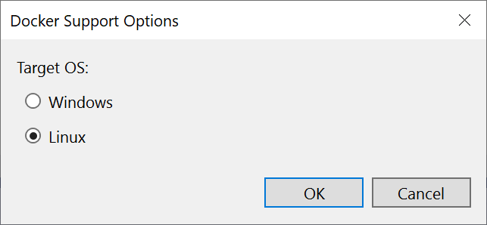

Visual Studio creates a *docker-compose.yml* file and a *.dockerignore* file in the **docker-compose** node in the solution, and that project shows in boldface font, which shows that it's the startup project.

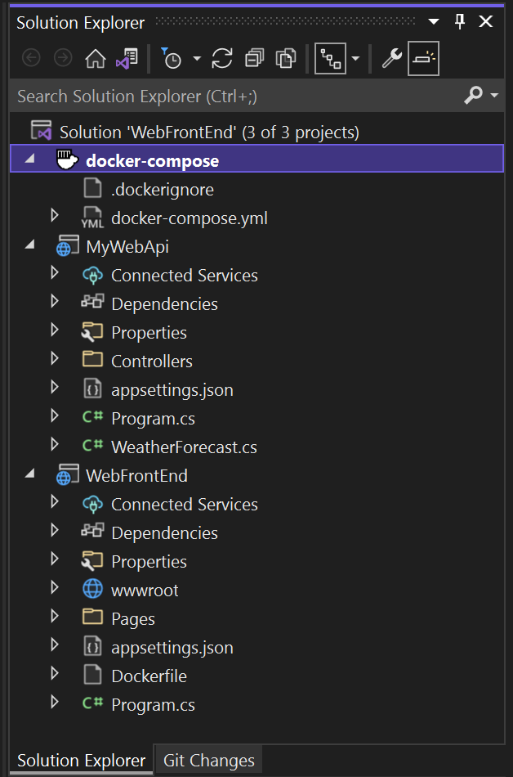

The *docker-compose.yml* appears as follows:

YAMLCopy

version: '3.4'

services:

webfrontend:

image: ${DOCKER_REGISTRY-}webfrontend

build:

context: .

dockerfile: WebFrontEnd/Dockerfile

The *.dockerignore* file contains file types and extensions that you don't want Docker to include in the container. These files are generally associated with the development environment and source control, not part of the app or service you're developing.

Look at the **Container Tools** section of the output pane for details of the commands being run. You can see the command-line tool docker-compose is used to configure and create the runtime containers.

1. In the Web API project, again right-click on the project node, and choose **Add** > **Container Orchestrator Support**. Choose **Docker Compose**, and then select the same target OS.

**Note**

In this step, Visual Studio will offer to create a Dockerfile. If you do this on a project that already has Docker support, you are prompted whether you want to overwrite the existing Dockerfile. If you've made changes in your Dockerfile that you want to keep, choose no.

Visual Studio makes some changes to your docker compose YML file. Now both services are included.

YAMLCopy

version: '3.4'

services:

webfrontend:

image: ${DOCKER_REGISTRY-}webfrontend

build:

context: .

dockerfile: WebFrontEnd/Dockerfile

mywebapi:

image: ${DOCKER_REGISTRY-}mywebapi

build:

context: .

dockerfile: MyWebAPI/Dockerfile

1. Add the Redis cache to the docker.compose.yml file:

ymlCopy

redis:

image: redis

Make sure the indentation is at the same level as the other two services.

1. The first project that you add container orchestration to is set up to be launched when you run or debug. You can configure the launch action in the **Project Properties** for the docker-compose project. On the docker-compose project node, right-click to open the context menu, and then choose **Properties**, or use **Alt**+**Enter**. For example, you can change the page that is loaded by customizing the **Service URL** property.

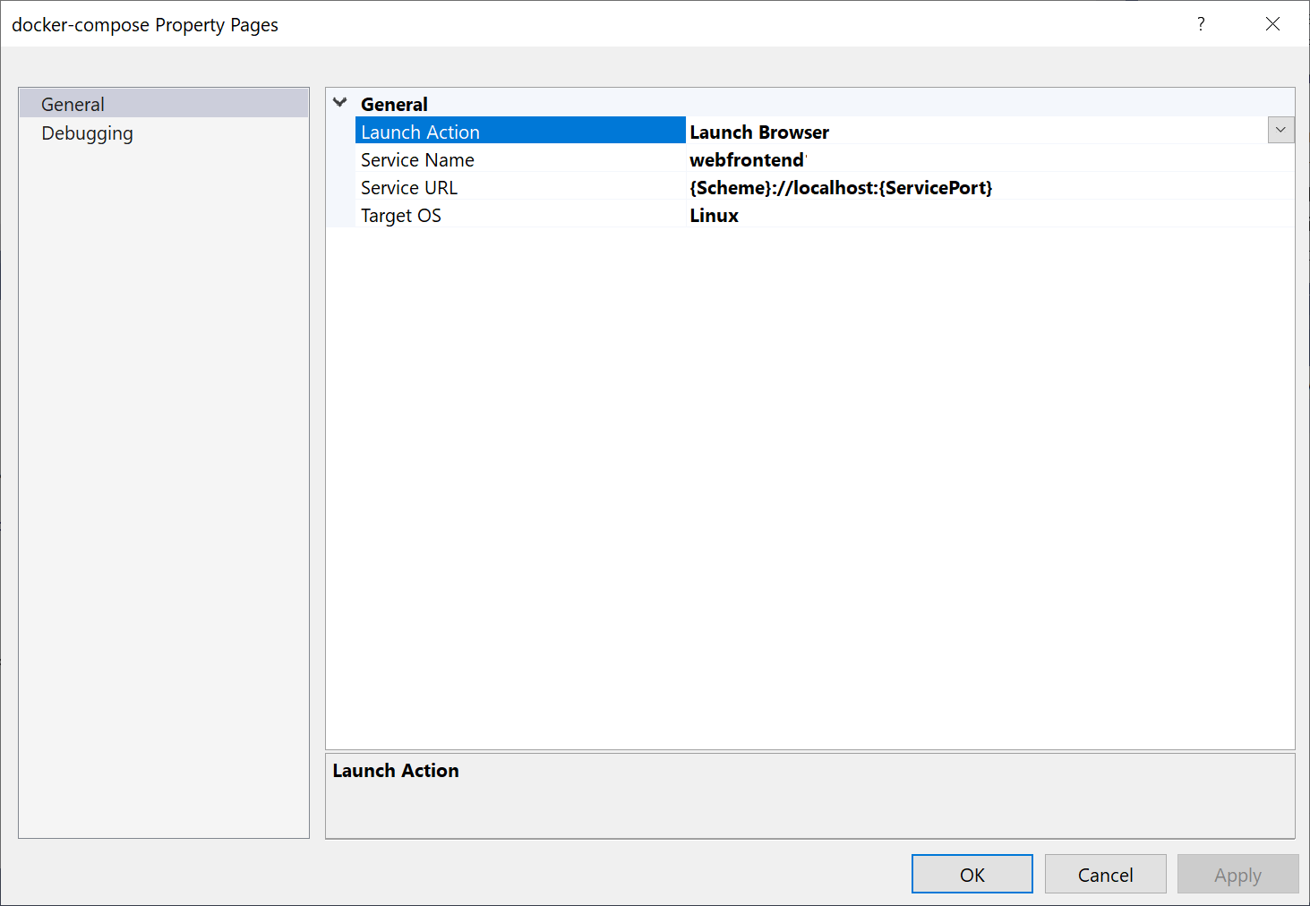

1. Press **F5**. Here's what you see when launched:

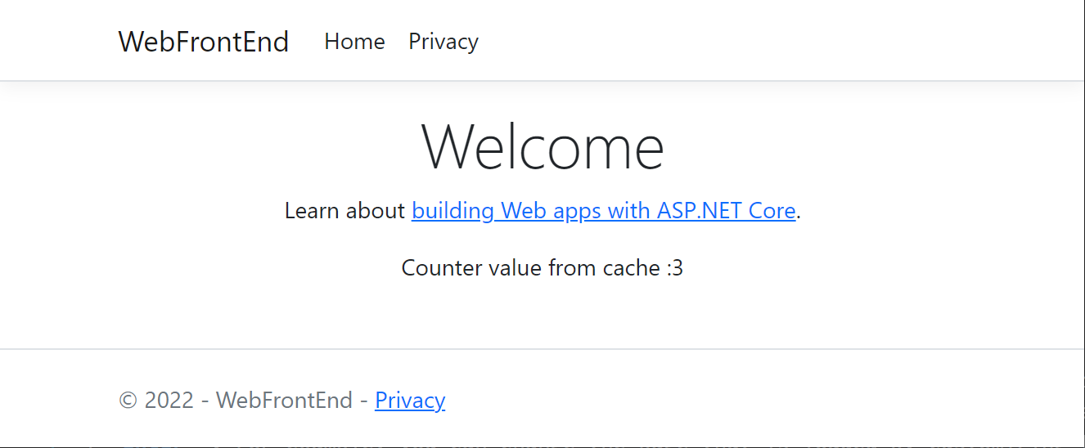

**Set up launch profiles**

1. This solution has a Redis Cache, but it's not efficient to rebuild the Redis cache container every time you start a debugging session. To avoid that, you can set up a couple of launch profiles, one profile that just starts the Redis cache, and another to start the other services, which will use the Redis cache container that's already running. From the menu bar, you can use the dropdown next to the start button to bring up a menu of debug options; choose **Manage Docker Compose Launch Settings**.

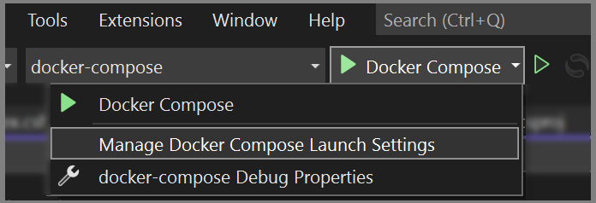

The **Manage Docker Compose Launch Settings** dialog comes up. With this dialog, you can control which subset of services is launched during a debugging session, which are launched with or without the debugger attached, as well as the launch service and URL. See [Start a subset of Compose services](https://docs.microsoft.com/en-us/visualstudio/containers/launch-profiles?view=vs-2022).

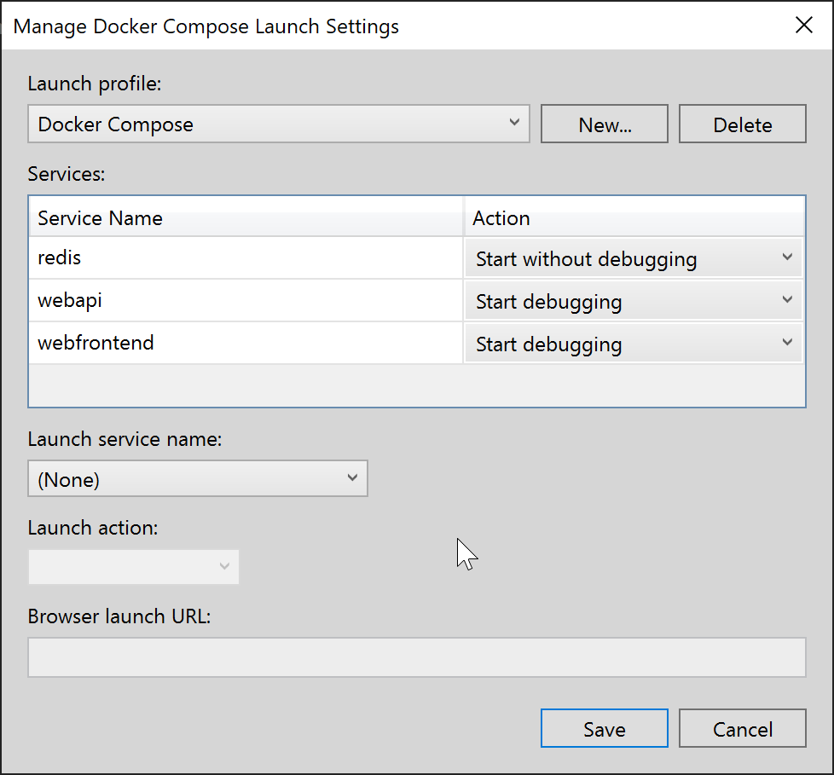

Choose **New** to create a new profile, and name it Start Redis. Then, set the Redis container to **Start without debugging**, leave the other set to **Do not start**, and choose **Save**.

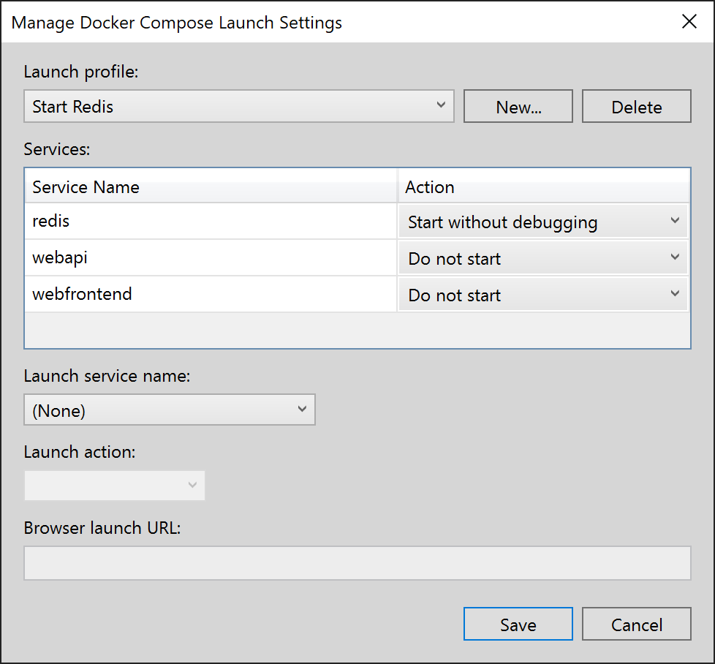

Then create another profile Start My Services that doesn't start Redis, but starts the other two services.

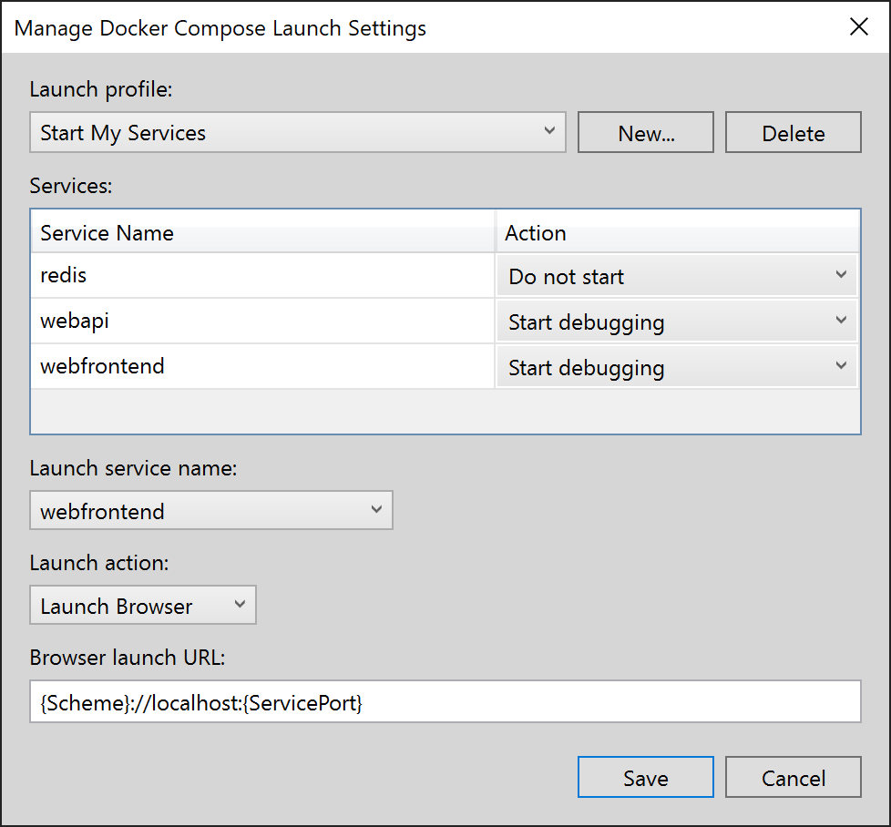

(Optional) Create a third profile Start All to start everything. You can choose **Start without debugging** for Redis.

1. Choose **Start Redis** from the dropdown list on the main Visual Studio toolbar, press **F5**. The Redis container builds and starts. You can use the **Containers** window to see that it's running. Next, choose **Start My Services** from the dropdown list and press **F5** to launch them. Now you can keep the Redis cache container running throughout many subsequent debug sessions. Every time you use **Start My Services**, those services will use the same Redis cache